Smart Bio floc Monitoring

**Eqra Khattak**

**Laraib Noor**

DEPARTMENT OF COMPUTER SCIENCES

COMSATS UNIVERSITY ISLAMABAD,

ATTOCK CAMPUS – PAKISTAN

SESSION 2018 – 2022

Smart Bio floc monitoring

*Undertaken by:*

**Eqra Khattak**

CUI/FA18-BSE-024/ATK

**Laraib Noor**

CUI/FA18-BSE-038/ATK

*Supervised by:*

**Dr. SAUD KHAN**

A DISSERTATION SUBMITTED AS A PARTIAL FULFILLMENT OF THE REQUIREMENTS FOR THE DEGREE OF BACHELOR OF SCIENCE IN SOFTWARE ENGINEERING

DEPARTMENT OF COMPUTER SCIENCES

COMSATS UNIVERSITY ISLAMABAD,

ATTOCK CAMPUS – PAKISTAN

SESSION 2018 – 2022

UNDERTAKEN

We certify that this is my/our own work. The work has not, in whole or in part, been presented elsewhere for assessment. Where material has been used from other sources it has been properly acknowledged. If this statement is untrue, we acknowledge that we will have committed an assessment offence and shall be liable to punishable action under the plagiarism rules of HEC.

_____________ _____________

Eqra Khattak Laraib Noor

FA18-BSE-024 FA18-BSE-038

Dated: ___________ Dated: _________

**FINAL APROVAL**

Certified that we have read this project report submitted by Miss Eqra Khattak and Miss Laraib Noor and it is, in our judgment, of sufficient standard to warrant its acceptance by Department of Computer Science, COMSATS University Islamabad, Attock Campus, for the BSSE degree.

***Committee:***

1. External Examiner ____________________________
2. Supervisor ____________________________

Dr. Saud Khan

Lecturer

CUI Attock

1. Head of the Department ____________________________

Dr. Khalid Mahmood Awan

HOD CS Dept.

CUI Attock

**Dedication**

To Sir Saud

**ACKNOWLEDGEMENT**

I must…

**PROJECT BRIEF**

PROJECT NAME SMART BIOFLOC MONITORING

ORGANIZATION NAME COMSATS UNIVERSITY ISLAMABAD, ATTOCK CAMPUS

OBJECTIVE TO MONITOR FISHES IN A BIOFLOC THROUGH A FLUTTER APP

UNDERTAKEN BY EQRA KHATTAK, LARAIB NOOR

SUPERVISED BY DR, SAUD KHAN

LECTURER

COMPUTER SCIENCE

CUI ATTOCK

STARTED ON 10TH SEPTEMBER 2021

COMPLETED ON TBD

COMPUTER USED DELL INSPIRON 5502 CORE i5

SOURCE LANGUAGE DART 2.14.4

OPERATING SYSTEM WINDOWS 10 PRO

TOOLS USED ANDROID STUDIO

**ABSTRACT**

Smart Bio floc Monitoring is a mobile application which will guide the fish farmer on how to do successful fish farming, from seed deployment to selling fish in the market. It will contain various sensors to look at the changed properties of water. A farmer can deal with all the cost subtleties and create various reports. In Pakistan, there is no consultancy for farmers to counsel for the development and medical problems of fishes. This thought is fundamentally for those farmers who are neglected to develop their business at a high proportion. The project contains a great deal of data and grandiosity in a novel technique for the fresher who needs to begin their startup as a fish farmer. They can read about how people succeed through this application for better suggestions they can easily get to know that in how much area of pound they can deploy the number of seeds. To examine the routine of water application can be used to determine, temperature, and the PH of the water. Feed and fertilizer to be given to the fishes taking care of the weather report. Also, according to condition marketplaces will be suggested for buying fish.

**TABLE OF CONTENTS**

Chapter 1 Introduction 1

1 Introduction 2

1.1 Brief 2

1.2 Objectives 3

1.3 Hardware Design 4

1.3.1 Components 4

1.3.2 ESP32 4

1.3.3 pH Sensor 5

1.3.4 Temperature Sensor 5

1.3.5 DFRobot – Analog TDS Sensor/Meter for Arduino SEN0244 6

1.3.6 Raindrop Water Level/Height Depth Detection Sensor Module for Arduino 7

1.3.7 Environment Monitoring Air Flow Sensor ENVIROMUX-AFM 7

1.4 Tools and Technologies 8

1.4.1 Android Studio 8

1.4.2 Flutter 8

1.4.3 Dart 8

1.4.4 Arduino web Editor 8

1.4.5 Firebase 8

1.5 Relevance to Course Modules 8

1.6 Project Background 9

1.7 Literature Review 9

1.7.1 IOT Based Fish Aquarium 9

1.8 System Conceptual Diagram 10

1.9 Analysis from Literature Review 11

1.10 Methodology and Software Lifecycle for This Project 11

1.11 The Rationale Behind Selected Methodology 11

Chapter 2 Problem Definition 13

2 Problem Definition 14

2.1 Problem Statement 14

2.2 Deliverables and Development Requirements 15

2.3 User Interface 15

2.4 Development Requirement Including Following Software Requirements 16

2.4.1 Frontend 16

2.4.2 Backend 16

2.4.3 Arduino 16

Chapter 3 Requirement Analysis 17

3 Requirement Analysis 18

3.1 Use Case Diagram(s) 18

3.2 Sequence Diagram 19

3.3 Detailed Use Case 19

3.3.1 Authentication 19

3.3.2 Area of Pond 20

3.3.3 Capacity 20

3.3.4 Feed Suggestion 20

3.3.5 Result from Sensors 21

3.3.6 Weather Forecast 21

3.3.7 Nearby Fish Market 22

3.3.8 Stock & Expenses 22

3.4 Functional Requirements 22

3.4.1 Capacity 23

3.4.2 Feed Suggestion 23

3.4.3 Nearby Market Suggestion and Managing Records 23

3.5 Non-Functional Requirements 23

Chapter 4 Design and Architecture 26

4 Design and Architecture 27

4.1 System Architecture 27

**LIST OF FIGURES**

Figure 1.1 ESP32 5

Figure 1.2 pH Sensor Kit 5

Figure 1.3 Temperature Sensor 6

Figure 1.4 Water level sensor 7

Figure 1.5 Air Flow Sensor 7

Figure 1.6 System Conceptual Diagram 10

Figure 1.7 Agile Model 12

Figure 3.1 Use Case Diagram 18

Figure 3.2 Sequence Diagram 19

Figure 4.1 System Architecture 27

Figure 4.2 Process Flow 28

Figure 4.3 Level 0 Data Flow Diagram 29

Figure 4.4 Level 1 Data Flow Diagram 30

Figure 4.5 Firebase Tree Structure 30

**LIST OF TABLES**

Table 3.1 Authentication 19

Table 3.2 Area of Pond 20

Table 3.3 Capacity 20

Table 3.4 Feed Suggestion 20

Table 3.5 Result from Sensors 21

Table 3.6 Forecast Use case 21

Table 3.7 Nearby Fish Market Use Case 22

Table 3.8 Stock & Expenses Use Case 22

Table 3.9 Non-Functional RE#01 23

Table 3.10 Non-Functional RE#02 24

Table 3.11 Non-Functional RE#03 24

Table 3.12 Non-Functional RE#04 24

Table 3.13 Non-Functional RE#05 24

**LIST OF ABBREVIATIONS**

# **Chapter 1**

# **Introduction**

## Introduction

Traditional fish farming is not sensitive to aquatic life as the ponds are already made, there’s always more water, more space, more fish and more of about everything but it has its perks. Such as, it can prove too unhealthy and contaminated for the fish to survive. The waste excreted by the fish and the leftover food can cause the formation of ammonia gas which is harmful for fish. In contrast, Bio floc is a symbiotic process that includes confined aquatic animals, heterotypic bacteria, and microbial species in the water. Bio floc provides environment that is good for fish growth and survival providing certain parameters are fulfilled. Consumption of bio flocs also provides nutritional value to cultured aquatic species.

Smart Bio Floc Monitoring is the monitoring of a bio floc in an artificially generated pond. This project will be an ultimately huge helping guide for bio floc fish farmers to do successful bio floc farming, from seed deployment to selling fish in the market. It will be looking into various factors such as monitoring sensors and their integration in the mobile app to look for any slight change in the properties of water or food. For example, oxygen level detection, temperature, pH, and water level etc. Also, to undergo the survival rate of fish in a pond according to its symmetry and then provide tips for its betterment. The sensors are directly connected to the mobile app and can be used remotely from anywhere to keep an eye on things. It can be used for both natural and artificial ponds.

## Brief

Smart Bio Floc Monitoring is a project based on a controlled synthetic environment which is highly suitable for survival and growth of a flock. Automated by a mobile application that runs on both Android and iOS with a single codebase Dart. This project is a simple program for a bio-flock fish farmer to help him in doing his job properly and efficiently with minimum efforts.

Computer literacy is a major issue in our country for farmers that are either on a small scale or in a large-scale production. They lack critical information about most of their farming practices and are unaware of the upgrade in resources. Numerous fish die in their ponds due to poor consideration.

Specifically, in Pakistan there’s no consultancy for farmers to consult for the growth, fertilization, and health issues of fish. Our objective is to provide them with the solutions to their problems so they can become better and successful fisherman of their region.

Considering the farmers must create artificial ponds in order to grow fish in ideal environments, there might be an issue with the area and the design of the pond. The problems can be a rectangular shaped pond which might stop the fish in their paths as fish tend to keep swimming most of the time, to avoid that, we decide to shape it circular.

It’s a fact that fish requires utmost care as their environment is different from land animals, so they need specific conditions like oxygen level, temperature, pH, water level, food etc. Fish feed is deployed according to the pound areas but first these parameters must be satisfied which will ultimately lead to reduction in fish death rate.

Survival area for 1000 fishes in a pond is 1 square meter. If 1 Acre farm is converted in to 1 single tank, a 1000 fish can survive. Parameters that must be met for bio floc are Temperature, Dissolved Oxygen, pH, Salinity, Solids (total suspended solids and settling solids), Alkalinity, and Orthophosphate. So, for its management, a technology called WSN (Wireless Sensor Network) is used in this project. WSN monitors and records the physical conditions of the environment and organize the collect data at a central location.

This project will decrease labor time and increase efficiency as it can be controlled from a mobile phone when installed on an Android or an iPhone. The sensors attached to the ponds will be integrated in the mobile app and the user will continuously examine the situation of the pond such as water quality and environment for better growth. In addition to that our app will advocate the best marketplace and farmers can manage all expenses and stocks record.



## Objectives

The objectives of this application are as follows:

* This application will suggest feed and fertilizers for the fish's growth based on the water temperature level, PH test, and weather prediction.
* To check the purity of water by checking its PH.
* To sense, observe the water temperature.

Manage all the details such as (Seed Expenses, Feed Expenses, and different Bills from the market) through our application.

* Users will get to know that how much seed they can deploy in the pound by providing the basic information of the pond.
* Users can easily contact fish hatcheries and the nursing point to get the best seed from them.
* Fish markets information will also be given.
* To transfer all the data to the mobile application.



## Hardware Design

In designing the hardware of our project, we have integrated all the components. The detailed explanation of each component is and its working has been explained in this chapter. We have also explained how different components are linked to each other.

### Components

In Hardware architecture, we have used the following components.

### ESP32

The ESP32 Wi-Fi Module is an independent SOC (system on chip) that can help any microcontroller to connect to the Internet with dual-mode Bluetooth and Wi-Fi. You can essentially attach this to your Arduino gadget and get about as much Wi-Fi-capacity as a Wi-Fi Shield offers. The ESP32 includes built-in antenna switches, RF balun, power amplifier, low- noise receive amplifier, filters, and power management modules. ESP32 is created by a Shanghai-based Chinese company and is manufactured by TSMC using their 40 nm process.

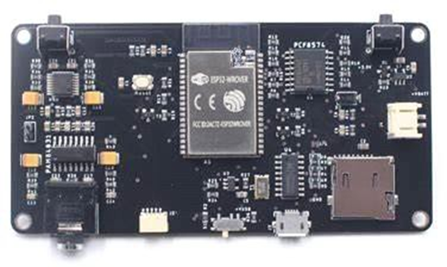

Figure 1.1 ESP32

### pH Sensor

PH sensor is used to measure hydrogen ion concentration in a solution. Glass pH electrode is widely used in pH sensors. The electrode is the main part of measuring the pH in a solution. It works on the principle of voltmeter and uses a potential difference to check solution voltages and compare them with existing ones. The ideal value for a solution should be pH=7 and if it is more than 7 it will a basic solution and if pH is less than 7then the solution will be acidic.

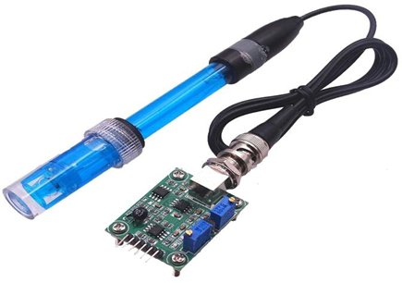

Figure 1.2 pH Sensor Kit

### Temperature Sensor

Temperature sensor plays an important role in many applications like in the case of fish farming it is necessary to check the temperature. Temperature sensors are usually thermocouple or RTD. We have used a thermistor-based temperature sensor, which is capable of monitoring water temperature. It works on the inverse time characteristics phenomena. The resistance of the thermistor decreases when the temperature increases and gives the signal of rising in temperature.

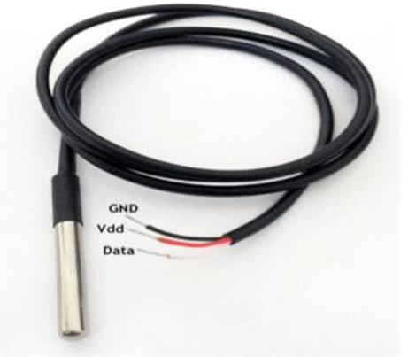

Figure 1.3 Temperature Sensor

### DFRobot – Analog TDS Sensor/Meter for Arduino SEN0244

This is an Arduino-compatible TDS sensor/Meter Kit for measuring TDS value of the water, to reflect the cleanliness of the water. It can be applied to domestic water, hydroponic and other fields of water quality testing.

TDS (Total Dissolved Solids) indicates that how many milligrams of soluble solids dissolved in one liter of water. In general, the higher the TDS value, the more soluble solids dissolved in water, and the less clean the water is. Therefore, the TDS value can be used as one of the references for reflecting the cleanliness of water.

TDS pen is a widely used equipment to measure TDS value. The price is affordable, and it is easy to use, but it is not able to transmit data to the control system for online monitoring to do some water quality analysis. The professional instrument has high accuracy and can send data to the control system, but the price is high for the ordinary people. To this end, we have launched an analog TDS sensor kit which is compatible with Arduino, plug and play, easy to use. Matching with Arduino controller, you can build a TDS detector easily to measure the TDS value of liquid.

This product supports 3.3 ~ 5.5V wide voltage input, and 0 ~ 2.3V analog voltage output, which makes it compatible with 5V or 3.3V control system or board. The excitation source is AC signal, which can effectively prevent the probe from polarization and prolong the life of the probe, meanwhile, increase the stability of the output signal. The TDS probe is waterproof, it can be immersed in water for long time measurement.

This product can be used in water quality application, such as domestic water, hydroponics. With this product, you can easily DIY a TDS detector to reflect the cleanliness of water to protect your health.

### Raindrop Water Level/Height Depth Detection Sensor Module for Arduino

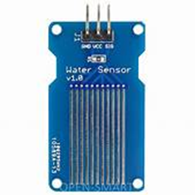

Figure 1.4 Water level sensor

### Environment Monitoring Air Flow Sensor ENVIROMUX-AFM

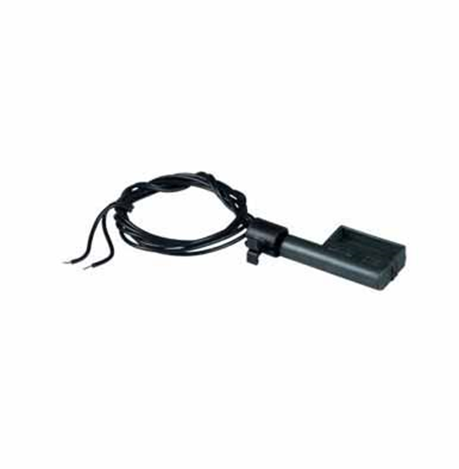

Figure 1.5 Air Flow Sensor



## 1.4 Tools and Technologies

The tools and technologies which we will be using for our project are:



### Android Studio

Android Studio is the IDE that provides Google to develop professional Android applications. It is used to develop a different variety of applications for the Android operating system. It is an IDE & platform to design a user-friendly interface by drag and drop.

### Flutter

Flutter is Google's UI toolkit for building beautiful, natively compiled applications for mobile, web, desktop, and embedded devices from a single codebase.

### Dart

Dart is an Open-Source, client-side programming language. It is easy to learn, stable, and creates high-performance applications.

### Arduino web Editor

The open-source Arduino Software (IDE) makes it easy to compose code and transfer it to the board.

### Firebase

For database operation firebase will be used to store the records.

## Relevance to Course Modules

As we studied different courses in the previous semester like Report writing skills. This course helps me a lot in improving my English and I am writing this report with help of it also programming, Database, software engineering, OOP in java, android, Applied physics for engineers. Android would be used for Designing interface and other functionality will be done by using different concepts of programming languages. In this project. Applied physics and Microprocessor and Assembly language will be used in Arduino Uno and hardware related work like Arduino Uno and for different sensors calibrations like PH, temperature, etc. In addition to that, the firebase database will also use for storing data. Software engineering will be favorable for us in making the use case diagrams activity diagrams.

## Project Background

The idea behind this project particularly occurred in our mind when the business encountered such Problems in fish farming. So, we prefer this idea because this is a profitable business in our country there are a lot of apps available which provide a guideline about the farming of fish some provide only tutorials which are not enough for a farmer, some app provided techniques, but they use some other languages, the only need is a farmer to have proper knowledge regarding how to feed fish, how to check the PH of the water. Also, lower-level farmers can use this application as our main target is to provide a maximum guideline about fishes that will help the farmers to grow their business on a high level. The feed is the main thing for fishes also users can check weather prediction this will be done by using different sensors like PH sensors as fish is dependent upon water to grow and breath, understanding the physical quality and chemical quality of water because success and failure depend on it. Less than 7 PH and greater than 8 PH are not suitable for fishes. Young fish may die to the PH level below. High PH levels above between 8 to 14 pH can be harmful for fish. One more sensor will be used i.e., Temperature sensor and weather predictions API will be used. For Selling sell their fishes Fish markets information will also be given. Users will get to know that how much seed they can deploy in the pound by providing the basic information of the pound.

## Literature Review

We look at the current system that is in use and state its strengths and weakness. Pakistan is an agricultural country, acknowledging the fact that fisheries play an important role in the life of humans and country development. In the past few years, fish farmers are facing numerous challenges such as type checking method for detecting fish’s health. These factors greatly affect the Economy of the country and food security. If we look at recent past years, there were several detection systems exist but when we talk about fish farming in Pakistan there is no consultancy for farmers to grow and health issues of fishes. By the time previous ways are replacing by the most efficient and latest ways, some current systems were made for the identification of fish.



### IOT Based Fish Aquarium

IoT Based fish aquarium is a fully automated and remotely monitored aquarium, fully capable of operating without human intervention or interaction. Major features of this project are the mechanical feed design, fish feeding over the internet, and remote monitoring of all the parameters. The parameters include feed level, water temperature, pH, and water level. They can be accessed through a website on a computer or through the app on a phone.

## System Conceptual Diagram

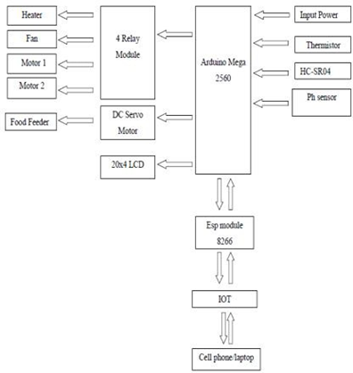

Figure 1.6 System Conceptual Diagram

In this project, they have used different types of sensors, which are connected to the microcontroller. Arduino gets the data from sensors, controls, and all the processes according to the commands given to it. The water level can also observe and refill the tank. This project has the following objectives

* To monitor the water level of the aquarium.
* To automate the refilling and drainage systems of the aquarium.
* In case if the aquarium is leaking or the water level drops to some extent it will refill the tank.
* To automatically feed the fishes at a specific interval of times.
* To check the purity of water by checking its ph.
* To transfer all the data to the internet.
* To make a system that can display and monitoring the sensor’s data online in real- time.
* To display the useful data of the aquarium on the screen

## Analysis from Literature Review

A thought comes to our mind from IoT based systems because humans do not do routine tasks very well and must discipline themselves over time, but machines or computers do not have these limitations. Every individual nowadays has cell phones, so our point is to create an android application, which handy & on the Go. We will provide the best solutions to their problems, attempting to incorporate everything in one application and propose the best market to sell their stocks. Our application will be beneficial for uniquely little scope farmers.it is effectively replaceable by a cell phone which is portable, time-Saving, and accessible at any time.

## Methodology and Software Lifecycle for This Project

The fundamental and building block of a project is to describe the methodology. The methodology is essential for managing the project. We make an all-around considered structure record, there are a few highlights that despite everything do not give a similar impact as it gave on the paper. During the execution stage, numerous highlights are included or altered. One needs to make a few changes in system design and requirement analysis. For creating of "Ultimate fishing guide", we have chosen a flexible model type that can be molded easily after designing. Used as an agile development methodology for the development of our model.

## The Rationale Behind Selected Methodology

Agile development is an interactive software development strategy that involves cooperation and self-organizational cross-functional teams. This involves the delivery of the project incrementally rather build and deliver the whole project at once. We must deliver a progress report to the supervisor on an incremental basis and on that we gradually develop this application. Henceforth, agile is a combination of methodology and technique.

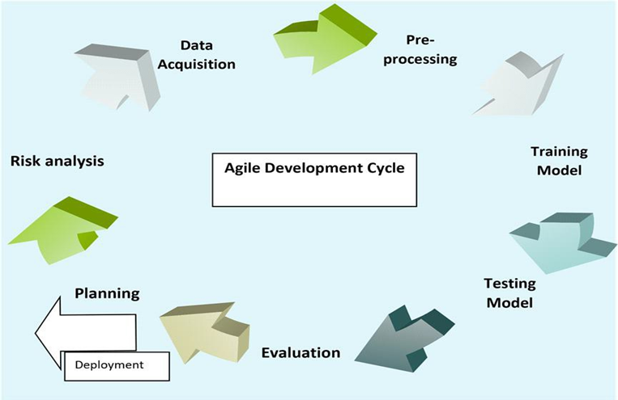

Figure 1.7 Agile Model

# **Chapter 2**

# **Problem Definition**

## Problem Definition

## Problem Statement

Considering the farmers must create artificial ponds in order to grow fish in ideal environments, there might be an issue with the area and the design of the pond. The problems can be a rectangular shaped pond which might stop the fish in their paths as fish tend to keep swimming most of the time, to avoid that, we decide to shape it circular.

It’s a fact that fish requires utmost care as their environment is different from land animals, so they need specific conditions like oxygen level, temperature, pH, water level, food etc. Fish feed is deployed according to the pound areas but first these parameters must be satisfied which will ultimately lead to reduction in fish death rate.

Survival area for 1000 fishes in a pond is 1 square meter. If 1 Acre farm is converted in to 1 single tank, a 1000 fish can survive. Parameters that must be met for bio floc are Temperature, Dissolved Oxygen, pH, Salinity, Solids (total suspended solids and settling solids), Alkalinity, and Orthophosphate. So, for its management, a technology called WSN (Wireless Sensor Network) is used in this project. WSN monitors and records the physical conditions of the environment and organize the collect data at a central location.

This project will decrease labor time and increase efficiency as it can be controlled from a mobile phone when installed on an Android or an iPhone. The sensors attached to the ponds will be integrated in the mobile app and the user will continuously examine the situation of the pond such as water quality and environment for better growth. In addition to that our app will advocate the best marketplace and farmers can manage all expenses and stocks record.

The major reason behind developing the ultimate fishing guide is to facilitate farmers either old or fresher because the government is assuming no job in preparing fish farming and giving them specialized help. They show their obliviousness on issues of how to think about the strength of the developing seed, their weight, and contrasts between the kinds of seeds Research on the possible species, taking care of and seeding advancement, and medical issues are the need of great importance. Most peoples don’t have access to higher levels for the seed, feed, and recovery from different diseases that a high-level farmer can easily manage thus their business doesn’t have a growth ratio as compared to other successful farmers. Several Fish identification Recommendations, and automated Fish farms controlling systems deployed for farmers using features of fishes to identify its health and maintaining other necessary problems. However, in a case wherein our country these techniques are failed due to ignorance of government we aim to provide an android application. Keeping in view the above performance problems; [Smart Bio floc Monitoring] is introduced for recommending feeds, seeds, and the best market for their stock. Users will get to know that how much seed they can deploy in the pound by providing the basic information of the pound.



## Deliverables and Development Requirements

When we launch our application. Users visit our application and know about the features of the smart Bio floc monitoring app the user must know about some basic knowledge that they can understand easily. While developing the Applications. We use android studio for Developing our screens. User will see all the following features in our application.

## User **Interface**

Android application is developed through which:

* Manage Expense Details
* Manage stock Details
* Results from sensors
* PH of water
* Weather predictions
* Temperature of water
* Temperature of environment
* Market place

## Development Requirement Including Following Software Requirements



### Frontend

Android studio (Flutter)

### Backend

Database: Firebase

Programming Languages: Dart

### Arduino

Attached with sensors

# **Chapter 3**

# **Requirement Analysis**

## Requirement Analysis

## Use Case Diagram(s)

It is the representation of the user with the system. It is used to describe the use cases (set of different actions) that can be performed by the actors (external users) by using the system. With the help of the use case, you can visualize the behavior of the system when the user uses it.

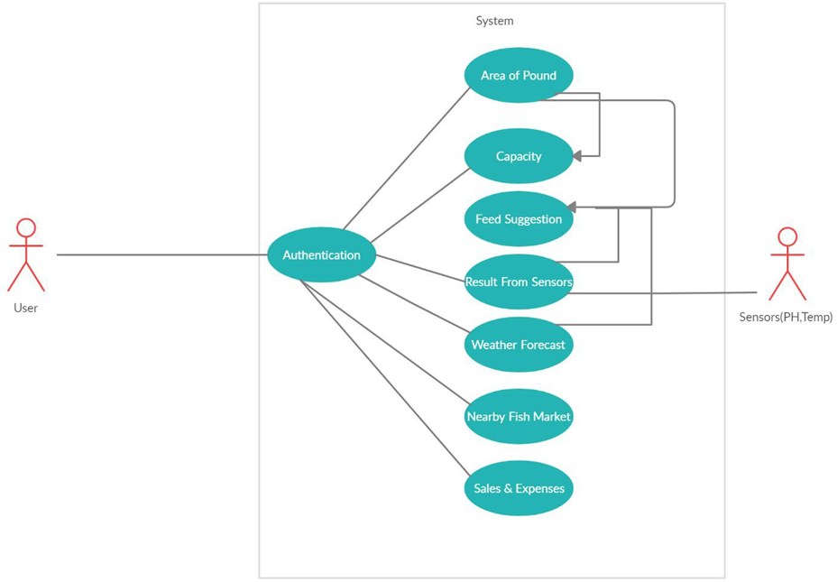

Figure 3.1 Use Case Diagram



## Sequence Diagram

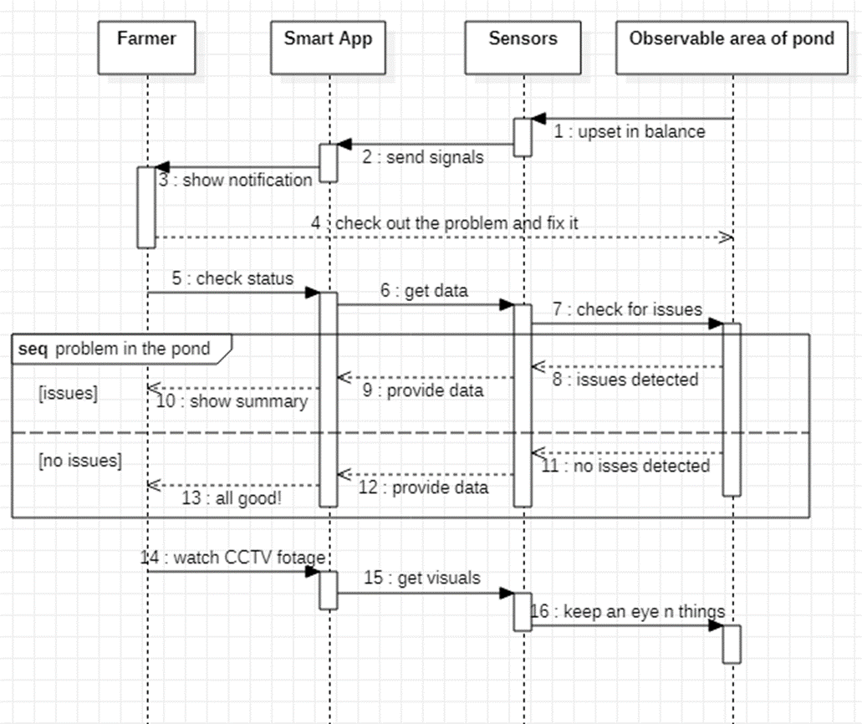

Figure 3.2 Sequence Diagram

## Detailed Use Case



### Authentication

Table 3.1 Authentication

|  |  |
| --- | --- |
| **Use-case name** | Authentication |
| **Actor** | User |
| **Description** | User will authenticate his/her phone No |
| **Pre-condition** | Users Login/Signup. |
| **Post-condition** | The user should get the desired outcome. |

### Area of Pond

Table 3.2 Area of Pond

|  |  |
| --- | --- |
| **Use-case name** | Area of pound |
| **Actor** | User |
| **Description** | The user must provide information about the area of the pound. |
| **Pre-condition** | Users must be using the application. |
| **Post-condition** | The user should get the desired outcome. |

### Capacity

Table 3.3 Capacity

|  |  |
| --- | --- |
| **Use-case name** | Capacity |
| **Actor** | User |
| **Description** | The user will get to know the number  of deployable seeds. |
| **Pre-condition** | User must have to Provide an area of a  pound. |

### Feed Suggestion

Table 3.4 Feed Suggestion

|  |  |
| --- | --- |
| **Use-case name** | Feed Suggestion |
| **Actor** | User |
| **Description** | The user will get to know the quantity and type of feed that must be given to the fishes. |
| **Pre-condition:** | User must have to Obtain All the Sensor result live from water using the sensors  i.e., PH temperature.  User must have to get Weather Forecast within the region from our application. |

### Result from Sensors

Table 3.5 Result from Sensors

|  |  |
| --- | --- |
| **Use-case name** | Result from Sensors |
| **Actor** | Sensors |
| **Description** | Using this Arduino sensor all the  Important test on the water is done which are important for fishes’ growth. |
| **Pre-condition** | All sensors must be attached to Arduino  and Arduino with our android app. |
| **Post-condition** | Based on test result feed suggestions are  Done. |

### Weather Forecast

Table 3.6 Forecast Use case

|  |  |
| --- | --- |
| **Use-case name** | Weather Forecast |
| **Actor** | User |
| **Description** | Weather API will be used for the  Prediction of forecasts in the region like expected rainfall and temperature. |
| **Pre-condition** | The app must have turned location ON and availability of internet  services |
| **Post-condition** | Based on Weather Forecast Feed Suggestions are done. |

### Nearby Fish Market

Table 3.7 Nearby Fish Market Use Case

|  |  |
| --- | --- |
| **Use-case name** | Nearby Fish Market |
| **Actor** | User |
| **Description** | Nearby Market places are given and there  will be proper route drawn toward them |
| **Pre-condition**. | Internet availability, enable Location |
| **Post-condition** | It should Suggest Market place. |

### Stock & Expenses

Table 3.8 Stock & Expenses Use Case

|  |  |
| --- | --- |
| **Use-case name** | Stock & Expenses |
| **Actor** | User |
| **Description** | User will Manage all of his/her  Expense and stock record using our database within the application. |
| **Pre-condition** | Multiple Databases must be created  for Each category. |

## Functional Requirements

Functional requirements are those functionalities that software must offer. It describes the basic behavior of the software. Functional requirements should include the details of functionality or operations provided by each screen. The complete workflow of the software should be made clear.

The following are the functional requirements of this project.



### Capacity

While starting up the APP the basic step is to check out the capacity of our pound how much seed can be deployable in it in our extensive environment. So, it is the basic requirement for the APP to provide it to the user.



### Feed Suggestion

After deployment of seed the major headache for the farmer is to provide the exact amount and type of feed otherwise it can cause the deaths of the fishes so through the proper test using sensor and predicted weather our app will provide farmer the exact amount and type of feed for their fishes.

### Nearby Market Suggestion and Managing Records

The goal of carrying out fishes to earn a healthy livelihood by selling the fishes in a manner to obtain desirable prices for them so our APP navigate toward nearby marketplaces to sell them. Also, it is a business rule to keep track of all the investments, expenses, and stocks so our APP will also provide a database for users to ensure safe record management.

## Non-Functional Requirements

Non-functional requirements show that how the system should perform certain functionality. Non-functional requirements generally deal with the quality of the software. Following are the non-functional requirements of this system:

Table 3.9 Non-Functional RE#01

|  |  |  |  |  |  |  |
| --- | --- | --- | --- | --- | --- | --- |
| **Name** | **Performance** | | | | | |
| **Summary** | Performance  application | defines | how | efficient | is | the |
| **Requirement** | The ultimate Fishing guide will be good in a performance like it will provide the user all the necessary information to carry out fishing from seeds to sell them in the market  involving most of the process with details | | | | | |

Table 3.10 Non-Functional RE#02

|  |  |
| --- | --- |
| **Name** | **Portability** |
| **Summary** | Portability means when using an application user is not restricted to use it by sitting on a fixed place or it does not need a different  system to operate |
| **Requirement** | It will be in your android mobile phone with  attached sensors which you always carry with you on your farm side. |

Table 3.11 Non-Functional RE#03

|  |  |
| --- | --- |
| **Name** | **Usability** |
| **Summary** | By usability of software, you mean that it  should be easy to learn. The user should not feel any difficulty in using this system |
| **Requirement** | In Ultimate Fishing Guide, we have included this in our priorities that this application should be user friendly, moreover it should  not be complex in its working mechanism |

Table 3.12 Non-Functional RE#04

|  |  |
| --- | --- |
| **Name** | **Compatibility** |
| **Summary** | It means to ensure that customer is satisfied or  not by testing. |
| **Requirement** | This application is compatible with the android operating system, it is being designed for specifically android OS. |

Table 3.13 Non-Functional RE#05

|  |  |
| --- | --- |
| **Name** | **Maintainability** |
| **Summary** | In which component can be modified to  improve performance. |
| **Requirements** | The requirement of maintainability is easily achieved in this application because first it is providing the functionality of user profile maintainability and all the basic record of the application is saved in the database. |

# **Chapter 4**

# **Design and Architecture**

## Design and Architecture

Following are the software diagrams of our project along with their descriptions.

## System Architecture

Our system architecture consists of 3 main modules: Frontend, Backend and Hardware. The frontend is an interactive interface that allows our users to visit our application and ease of use. Users can monitor the basic requirements for ideal pond conditions such as Oxygen level, pH of water, temperature, and other nutrients crucial for the fishes’ survival. Feed suggestions, latest updates on farming technologies and practices and the nearest Fish Market through Google Map. The results are displayed on the screen. Our project architecture diagram is shown below:

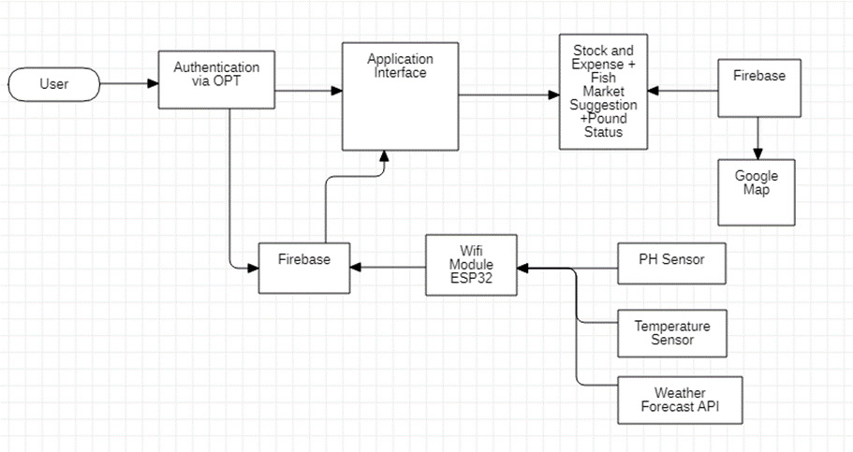

Figure 4.1 System Architecture

This diagram explains how the overall interaction between user and application takes place. A user interacts using the android interface which is used to control the whole process and background processing. The application gets input through different sensors which are PH sensors and temperature sensors also user can check the current weather of his city. Users can add multiples pond information and can easily Manage every pond data which includes the area of a pond. This application will suggest the best marketplace to sell fishes users will follow the direction of the market by Google map API. Also, the user will maintain its record in the database.

* 1. **Data Representation [Diagram + Description]**

It contains different symbols & connectors. It is known as graphical representations between people and objects. An ER model is made of an entity and some specific relationships which exist between entities.

* 1. **Process Flow [Representation]**

It is a way of representing the flow of data through the system.it provides information about the outputs and inputs of entities and processes.it shows a complete flow of data between system modules. Ultimate fishing guide main modules are a value of PH of the water, suggest Nearby Fish Market, and gives a feed suggestion According to Area of a pound. The application will take input i.e., water pH, temperature from the user, and give results. Following is a data flow diagram of the ultimate fishing guide app.

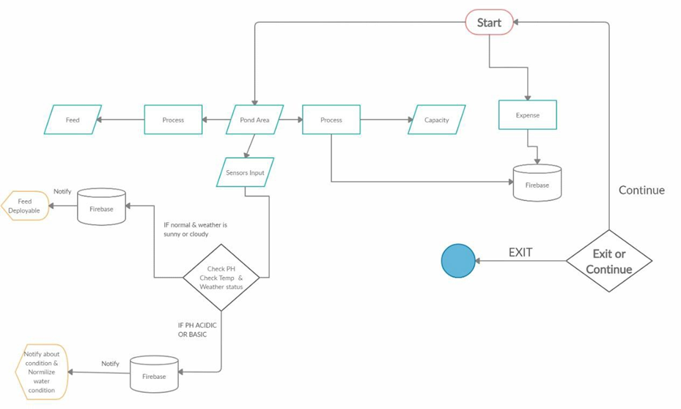

Figure 4.2 Process Flow

The figure demonstrates the data process of the overall system that how a user will operate our application. To do this he will first look for seed information by giving an area of a pound. The further user gives input to the system using a sensor then these sensors upload this data to our firebase and the firebase sent a notification to the farmer to generate respective output. Also, our firebase contains data about pond status including area, so it suggests feed to the farmer too. When the farmer is done using the application, he can exit the process and leave!

* 1. **Data Flow Diagram [Level Zero]**

User

Figure 4.3 Level 0 Data Flow Diagram

In 0 level we have 2 entities “user” and “application”. Users can see Multiple options like pond status, manage expenses & stokes, and weather prediction through our app user will also get to know about feed suggestions. In Figure 41, the system architecture diagram of the "Ultimate fishing guide" application is shown, represents that the user can check the value of ph. and can check the temperature. Based on these values and weather prediction user can deploy a suitable feed. Users will find the best marketplace. Availability of internet is necessary.

* 1. **Data Flow Diagram [Level 1]**

The complete flow and functionality of each module have been shown in the figure below.

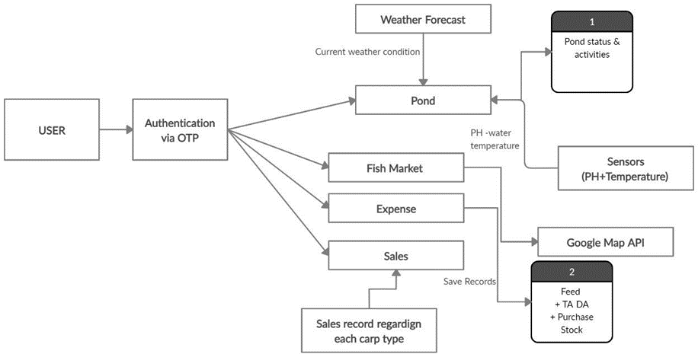

Figure 4.4 Level 1 Data Flow Diagram

* 1. **Tree Structure for Firebase**

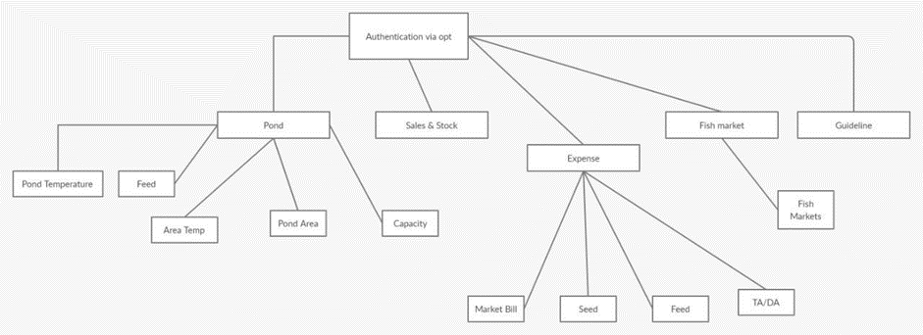

Figure 4.5 Firebase Tree Structure

This Diagram shows the full structure of our firebase nodes and their hierarchy. The root node is the authentication node under that all the application hierarchy is explained in this tree structure. As our pond’s node contains multiple child nodes all the graphical information about these child nodes is being explained in a diagrammatical manner. The expense node contains all the data about sales and expenditures in its child nodes.

**Appendix A**

**List of Reference Variables**